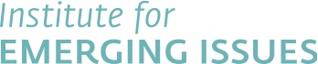

Media contact:
Ginny Inman FOR IMMEDIATE RELEASE
(919) 515-9254
getyson@ncsu.edu
GRANTS AWARDED TO THREE LOCAL SCHOOL SYSTEMS
$17,500 to Fund Local Programs Designed to Enhance Teacher Effectiveness

Today, the Institute for Emerging Issues (IEI) and the Belk Foundation awarded a total of $17,500 in grants to three teams to support efforts to enhance teacher effectiveness in local communities.

School system teams from Catawba, Greene, and Lee counties received grants to address different needs of educators in those communities. IEI evaluated a total of 32 applications from across the state. Each plan was judged on competitive criteria including clarity and feasibility, collaboration among educators, budget, and impact on North Carolina. All proposals were required to include at least one classroom educator, one school administrator, and one community member.

“Effective educators benefit not just our students but entire communities,” said Anita Brown-Graham, IEI director. “This funding will aid communities as they seek new ways to increase teacher effectiveness, which in turn will enhance North Carolina’s economic competitiveness.”

Grants were awarded for the following efforts:
- Juan Castillo and team from Greene County Schools received $10,000 for “Communication and Cultural Awareness,” a program to bridge cultural gaps between teachers and Latino families. This effort will increase parental involvement and community support for teachers.
- Dr. Carol Moore and team from Catawba County Schools received $4,500 for “Real Life Issues: Project/Problem-Based Learning Development,” that will enable five teachers to spend time shadowing local STEM (science, technology, engineering, and mathematics) professionals. The teachers will then build curriculum tied to local STEM activities to help meet local workforce needs.
- Patricia Coldren and team from Lee County Schools received $3,000 for “Take the Lead,” a plan to build stronger support networks for beginning teachers through lead teacher mentoring, enhanced professional development opportunities, and connecting teachers to community resources.

This past February, IEI’s annual Emerging Issues Forum, Teachers and the Great Economic Debate, focused on the long-term impact of highly effective teachers on students and the state’s economy. More than 1,300 individuals from nearly every county and all industry sectors worked together to develop a list of priorities about how best to attract and retain highly effective teachers. Afterwards, IEI coordinated a “Massive Open Online Course” (MOOC) entitled “World Class Teaching.” Participants of the MOOC were encouraged to submit plans for community action project funding.

For additional information on the three winning proposals, click here.

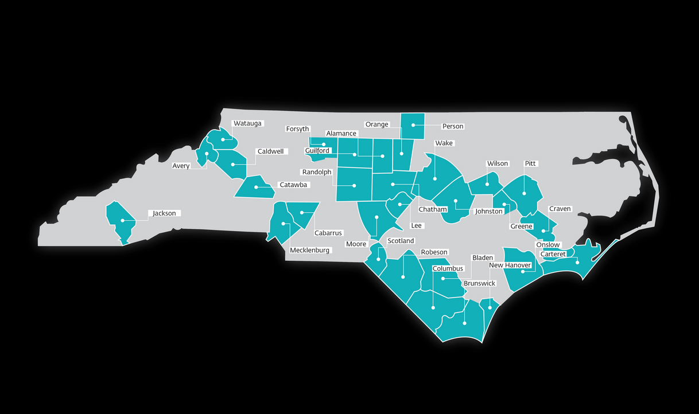
Thirty-two teams from 3o counties across North Carolina entered for their chance to win $17,500 through the Institute for Emerging Issues (IEI) and the Belk Foundation’s Community Action Plan Grant competition. Click here for a high-resolution copy of this map.

Background on IEI:

Established in 2002, the Institute for Emerging Issues (IEI) connects people and resources from all sectors and areas of North Carolina in an effort to ensure our state’s future competitiveness. Every February, IEI’s Emerging Issues Forum attracts leaders in business, education, and public policy to discuss a key challenge facing our state. By supporting collaboration among individuals from a variety of perspectives and backgrounds, IEI builds an enduring capacity for progress. For more information on IEI’s work, visit www.emergingissues.org

####

